This first page of the full paper is the Structured Abstract

Title of the Paper
(The title of the paper must be in title case, 14pt, Times New Roman, Bold )
First Author Nameª (First, Last); Second Author Name^{b}, and etc ^{c}.
First Author Affiliationª, Second Author Affiliation (if different)^{b} , Subsequent Author Affiliation^{c}
Corresponding Author Email:
(Author name must be in 11pt font. Author affiliation must be in 10 pt Italic.Email address must be in 9 pt font Italic. Author details must not show any professional title. The superscript ‘ª’ is not required when all authors are from the same institution)

rationale
Provide a brief background or explanation of the general context of the study or the principlesemployed in the conceptualization and conduct of the study.
(4 – 5 sentences)
objectives
Briefly explain what you intended to attain or accomplish in the study within atime frame and with availableresources. (Maximum of 4 sentences)
methodology
Include a brief description of the methods applied to various facets within the scope of the study, the data or evidence collected, and the manner by which these were analyzed. (3 sentences)
RESULTS
Summarize the outcomes and relevant findings of the study. Significant results should be clearly described.
(2 – 3 sentences)
CONCLUSIONS
Include conclusions on the basis of the evidence presented and how they compare to what is currently known about the topic. (2-3 sentences)
KEYWORDS
Include a maximum of 5 relevant keywords.

1. INTRODUCTION
The paper should generally contain: Introduction; Objectives; Materials and Methods; Results and Discussion; Conclusions; Recommendations; and References. You should submit a full paper for oral or poster presentation. The following guidelines will provide complete information on the preparation of your full paperto ensure compliance to the criteria for the peer review process. Full papers will be subjected to blind peer review process where evaluators will assess the paper without knowing the identity of the authors. Likewise, the authors will not have knowledge about the background of the evaluators. Finally, a “camera-ready” version of the paper incorporating all the evaluators’ comments should be submitted for inclusion to the conference proceedings. The Conference Proceedings will be provided to the participants inPDF format saved in a flash drive, which will be part of the conference kit.

2. PAPER PREPARATION GUIDELINES
All text must be in a two-column format (4.22 mm (0.17") between columns and fully justified. Do not write or print anything outside the print area defined in these guidelines. Each full paper is limited to a maximum length of 9 pages including the Structured Abstract, figures, tables, and references.

2.1Style, Font and Spacing
The main text must be Normal, fully justified 10-pt Times New Roman type and single-line spacing. Italic type may be used to emphasize words in running text. Main headings should be all capitalized, 12-pt Times New Roman, bold and numbered. For subheadings, all words except articles, prepositions, and conjunctions should be set with an initial capital and boldface.
The first paragraph in each section should not be indented, but all following paragraphs within the section should be indented as these paragraphs demonstrate.

2.2Paper Size, Margins and Pagination
The draft and camera-ready versions should be placed on A4-size sheets of paper. Left margin for the text shall be 1.25”, 0.8” for the right margin, and 1.00” for the top and bottom margins. Papers submitted (draft or camera ready) should not include page numbers.

2.3Figures and Tables
Figure and table captions as well as callouts should be 9-point Times New Roman font, boldface and centered. Initially capitalize only the first word of each figure caption and table title. Figure captions are to be placed below the figures as in Figure 1. Table titles are to be above the tables as in Table 1. Use the full format “Figure 1” rather than an abbreviated format “Fig. 1” when referring to a figure or table within the body of the paper. A table or figure should be preceded and followed with one line (space) free to the adjoining paragraphs.

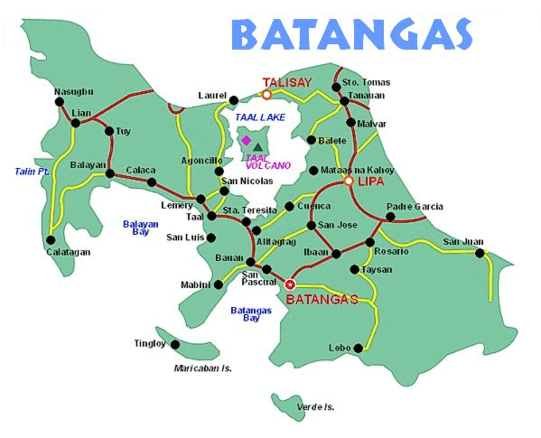
Figure 1. Captions should be centered.

Table 1. Formats of headings
Heading level | Font | Example
1st-order | 12pt bold | 1.INTRODUCTION
2nd order | 11pt bold | 2.1 Second-order
3rd order | 10pt bold | 3.1.1 Data Set

2.3.1Headers, footers and footnotes.
Do not use headers, page numbers, and footnotes in the full paper.

2.4Illustrations, Graphs, and Photographs
All graphics should be center-justified with a self-contained caption. Please ensure that the graphs and figures are clearly readable when reproduced in hard copy. Texts in figures and graphsmust be resized accordingly. Reviewers may opt to print your paper in order to evaluate it better.

2.5 Mathematical Symbols and Equations
All equations should be accomplished using Equation Editor or any other word processors and ‘Cross-referenced’, as shown in Eq. (1)
(1)

REFERENCES
IEEE reference format should be followed. List and number all bibliographical references in 9-point Times New Roman, single-spaced, at the end of your paper. When referenced in the text, enclose the citation number in square brackets, for example [1]. Where appropriate, include the name(s) of editors of referenced books.

[1] D. E. Goldberg, “Genetic Algorithms in Search, Optimization and Machine Learning”. New York: Adison-Wesley, 1989.
[2] G.J. Lim, G.D. Hong, andM.H. Kim, Multimedia and Imaging Databases, Morgan Kaufmann Publishers, San Francisco, Calif., 2005.

Acknowledgements
An acknowledgements section can be included after the References. Use second level heading with normal text style.

Copyright statement
A copyright statement should be included at the end of your paper as shown below.
Copyright © 2017 Names of authors: The authors assign to IRCIEST- BatStateU a non-exclusive license to use this document provided that the article is used in full and this copyright statement is reproduced. The authors also grant a non-exclusive license to IRCIEST- BatStateU to publish this document in full on the World Wide Web, on Flash Drives, and in printed form within the IRCIEST conference proceedings. Any other usage is prohibited without the expressed permission of the authors.

